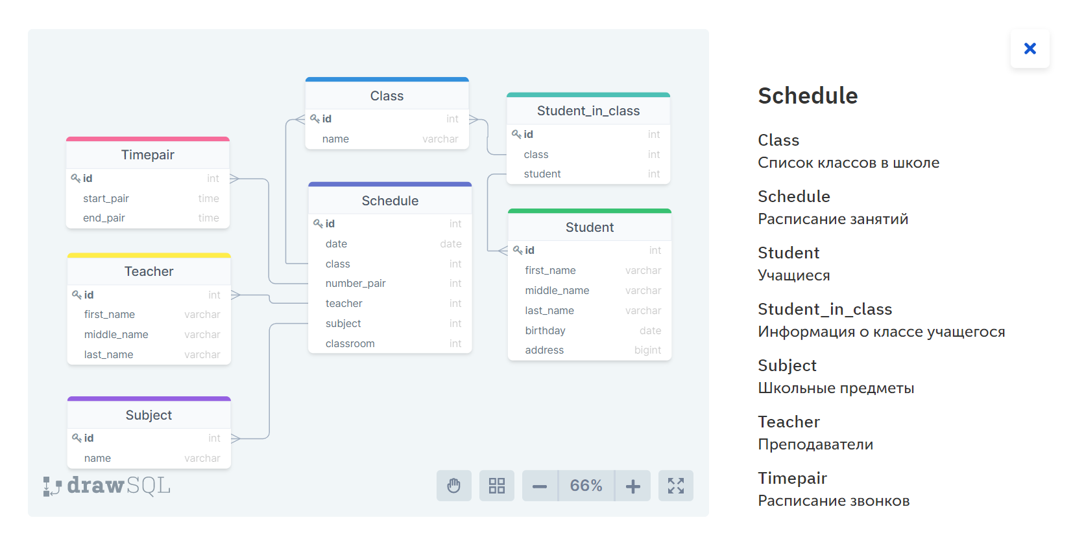

Какой процент обучающихся учится в 10 А классе ?

SELECT ROUND( CAST (COUNT(SIC.id) AS FLOAT)/

(SELECT COUNT(id)

FROM Student_in_class)*100,2) AS [% of students in 10 A]

FROM Student_in_class SIC INNER JOIN Class C ON SIC.class=C.id and C.name = "10 A"

Сколько обучающихся в 10 Б классе?

SELECT COUNT(SIT.id) AS Quantity

FROM Student_in_class SIC INNER JOIN Class C ON SIC.class=C.id and C.name = "10 Б"

У каких классов 3го сентября 2018го года первым уроком была математика 'math' ?

SELECT C.name

FROM Class C INNER JOIN Schedule S ON C.id = S.class AND number_pair = 1 AND S.date = '2018-09-03'

INNER JOIN Subject SB ON S.subject = SB.id AND SB.name = 'math'

Какой учитель ведет занятия у наибольшего числа обучающихся?

SELECT TOP 1 with ties T.first_name +' '+T.last_name AS FullName

FROM Teacher T INNER JOIN Schedule SCH ON T.id = SCH.teacher

INNER JOIN Class C ON SCH.class = C.id

INNER JOIN Student_in_class SIC ON C.id=SIC.class

GROUP BY T.first_name +' '+T.last_name, T.id

ORDER BY COUNT(DISTINCT SIC.id) DESC

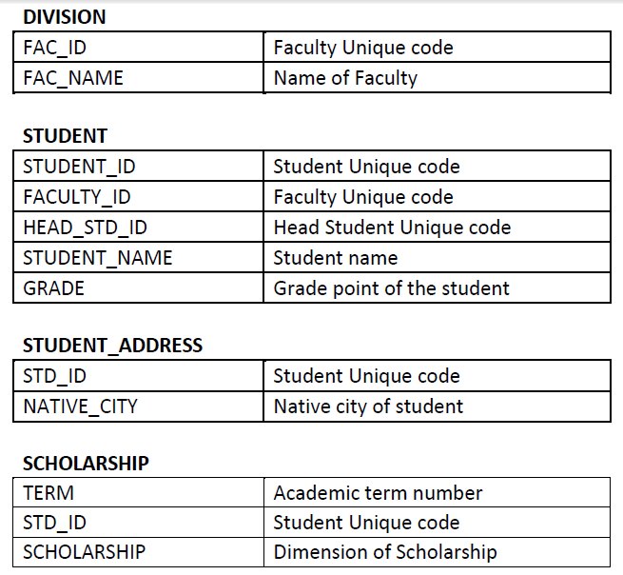

1. Find the list of faculties with maximum sum grade points of students

SELECT TOP 1 WITH TIES D.FAC_NAME

FROM DIVISION D INNER JOIN STUDENT S ON D.FAC_ID = S.FACULTY_ID

GROUP BY FAC_NAME, FAC_ID

ORDER BY SUM(GRADE) DESC

2. Get the list of students, having grades more than their head student

SELECT STUDENT_NAME

FROM STUDENT

WHERE GRADE > (SELECT GRADE

FROM STUDENT S1

WHERE S1.STUDENT_ID = STUDENT.HEAD_STD_ID

)

3. Get the list of students from your city, which grade more than the average grade of the faculty

SELECT S.STUDENT_NAME

FROM STUDENT S INNER JOIN STUDENT_ADDRESS SA ON S. STUDENT_ID = SA. STD_ID

AND NATIVE_CITY = ‘Moscow’

WHERE GRADE > (SELECT AVG(GRADE)

FROM STUDENT S1

WHERE S.FACULTY_ID = S1.FACULTY_ID

)

4. Take the top 5 best students by the sum of scholarship in this term excluding the top 5 best students by the sum of scholarship in the previous term.

SELECT TOP 5 WITH TIES STUDENT

FROM (

SELECT S.STUDENT_NAME, SUM(SCHOLARSHIP) AS Total

FROM STUDENT S INNER JOIN SCHOLARSHIP SH ON S. STUDENT_ID = SH. STD_ID

WHERE TERM = (SELECT MAX(TERM)

FROM SCHOLARSHIP)

GROUP BY S. STUDENT_ID, S.STUDENT_NAME

EXCEPT

SELECT TOP 5 WITH TIES S.STUDENT_NAME, SUM(SCHOLARSHIP) As Total

FROM STUDENT S INNER JOIN SCHOLARSHIP SH ON S. STUDENT_ID = SH. STD_ID

WHERE TERM = (SELECT MAX(TERM)

FROM SCHOLARSHIP) - 1

GROUP BY S. STUDENT_ID, S.STUDENT_NAME

ORDER BY SUM(SCHOLARSHIP) DESC

) AS STUDENTS_CUR_TERM

ORDER BY Total DESC

Набор данных:

Date – дата продажи,

Distributor - дистрибьютор,

POS_ID - точка продажи,

SKU - продаваемый продукт,

Region - регион,

Employee - сотрудник,

Units - продано в упаковках,

Gross_Sales - в деньгах.

1. Вывести список из 10 крупнейших дистрибьюторов по общему объёму продаж с начала года (YTD), сортировка от большего к меньшему.

Необходимые поля:

Distributor,

YTD - объем продаж в деньгах с начала года,

YTD PY - объем продаж в деньгах за аналогичный период, как YTD, но год назад,

MAT - объем продаж в деньгах за последние 12 месяцев.

__________________________________________________________________________

SELECT TOP 10 WITH TIES Distributor,

SUM(CASE WHEN Date > CONVERT(DATE, DATEADD(YEAR, DATEDIFF(YEAR, 0, GETDATE()), 0)) THEN Gross_Sales END) as ‘YTD’,

SUM(CASE WHEN Date BETWEEN CONVERT(DATE, DATEADD(YEAR, DATEDIFF(YEAR, 0, GETDATE()) - 1, 0)) AND CONVERT(DATE, DATEADD(YEAR, -1, GETDATE())) THEN Gross_Sales END) as ‘YTD PY’,

SUM(CASE WHEN Date > CONVERT(DATE, DATEADD(YEAR, -1, GETDATE())) THEN Gross_Sales END) as 'MAT'

FROM T

GROUP BY Distributor

ORDER BY ‘YTD’ DESC

1. Вывести точки продаж (pos_id), где за последние 6 месяцев продажи каждый месяц были больше 10 упаковок

Необходимые поля:

POS_ID

_______________________________________________________________

WITH Table_6m AS (

SELECT Date, POS_ID, Units

FROM T

WHERE Date > CONVERT(DATE, DATEADD(MONTH, -6, GETDATE()))

) ,

Units_Pos_ID AS (

SELECT POS_ID, MONTH(Date), SUM(Units) AS Units_per_month

FROM Table_6m

GROUP BY POS_ID, MONTH(Date)

)

SELECT POS_ID

FROM Units_Pos_ID

GROUP BY POS_ID

HAVING SUM( CASE WHEN Units_per_month > 10 THEN 1 END) = 6

1. Вывести общие продажи по сотруднику (Employee) за последние 12 месяцев с указанием доли каждого SKU

Необходимые поля:

Employee – сотрудник,

Gross_Sales – результат продаж в деньгах,

SKU_1 Share – Доля SKU_1 %,

SKU_2 Share – Доля SKU_2 %,

SKU_3 Share – Доля SKU_3 %

______________________________________________________________

SELECT Employee, SUM(Gross_Sales) AS Gross_Sales,

ROUND(SUM(CASE WHEN SKU =1 THEN Gross_Sales END)/ CAST(SUM(Gross_Sales) AS FLOAT) * 100 ,2) AS ‘SKU_1 Share’,

ROUND(SUM(CASE WHEN SKU =2 THEN Gross_Sales END)/ CAST(SUM(Gross_Sales) AS FLOAT) * 100 ,2) AS ‘SKU_2 Share’,

ROUND(SUM(CASE WHEN SKU =3 THEN Gross_Sales END)/ CAST(SUM(Gross_Sales) AS FLOAT) * 100 ,2) AS ‘SKU_3 Share’

FROM T

WHERE Date > CONVERT(DATE, DATEADD(YEAR, -1, GETDATE()))

GROUP BY Employee